EXP 1

Program 1 — Capacity estimate for FDMA, TDMA and CDMA

Objective 1: To estimate and compare the illustrative number of users supported by FDMA,
TDMA and CDMA using the specified system parameters

MATLAB program:

% Comparison of FDMA, TDMA and CDMA
% Simplified illustrative model; not a full cellular-network simulation.

clear; clc; close all;

% Illustrative system parameters
totalBandwidthHz = 1e6; % Total bandwidth: 1 MHz
fdmaChannelHz = 200e3; % FDMA channel width: 200 kHz
tdmaSlots = 8; % Number of TDMA slots per frame
processingGain = 64; % CDMA processing gain
targetSIRdB = 7; % Minimum acceptable CDMA SIR

% Capacity estimates under the stated assumptions
fdmaUsers = floor(totalBandwidthHz / fdmaChannelHz);
tdmaUsers = tdmaSlots;
targetSIR = 10^(targetSIRdB / 10);
cdmaUsers = floor(1 + processingGain / targetSIR);

fprintf('Illustrative maximum supported users\n');
fprintf('FDMA: %d users\n', fdmaUsers);
fprintf('TDMA: %d users\n', tdmaUsers);
fprintf('CDMA: %d users at a target SIR of %.1f dB\n\n', ...
cdmaUsers, targetSIRdB);

% CDMA SIR as the number of simultaneous users increases
K = 2:30;
sirLinear = processingGain ./ (K - 1);
sirDb = 10 * log10(sirLinear);

% Display a comparison table
method = ["FDMA"; "TDMA"; "CDMA"];
supportedUsers = [fdmaUsers; tdmaUsers; cdmaUsers];
results = table(method, supportedUsers, ...
'VariableNames', {'Method', 'SupportedUsers'});
disp(results);

% Plot estimated user capacity
figure;
bar(categorical(method), supportedUsers);
ylabel('Illustrative maximum supported simultaneous users');
title('FDMA, TDMA and CDMA: Capacity Estimate');
grid on;

% Plot estimated CDMA SIR as users are added
figure;
plot(K, sirDb, 'o-', 'LineWidth', 1.5);
hold on;
yline(targetSIRdB, '--r', 'Target SIR');
xlabel('Number of simultaneous CDMA users (K)');
ylabel('Estimated SIR (dB)');
title('Estimated CDMA SIR versus Number of Users');
grid on;
hold off;

OUTPUT:
Illustrative maximum supported users
FDMA: 5 users
TDMA: 8 users
CDMA: 13 users at a target SIR of 7.0 dB
Method SupportedUsers
______ ______________
"FDMA" 5
"TDMA" 8
"CDMA" 13

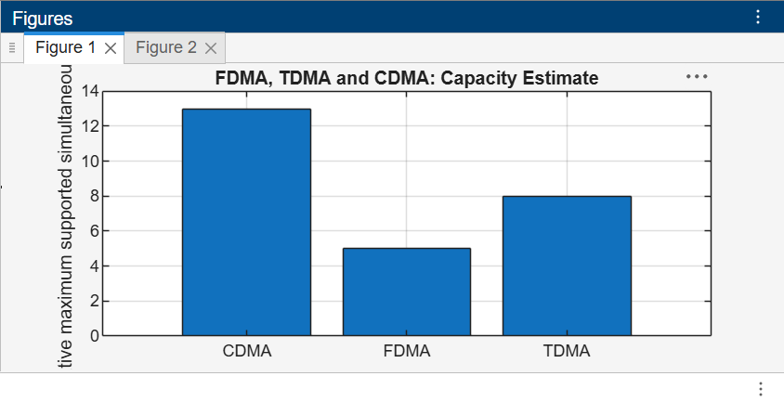

Objective 2: CDMA SIR analysis:

To analyze how the estimated CDMA signal-to-interference ratio changes as the number of simultaneous users increases.

Finding out the SIR for the technique with the highest number of users

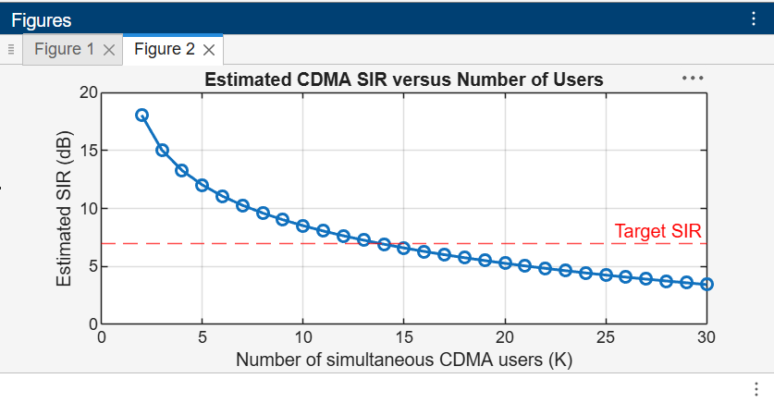
Objective 3: Mobile-generation comparison:

To relate representative multiple-access techniques to the evolution of mobile communication systems from 1G to 5G.

MATLAB Program:

generation = ["1G"; "2G"; "2G"; "3G"; "4G"; "5G"];
system = ["AMPS"; "GSM"; "IS-95"; "UMTS"; "LTE"; "5G NR"];
accessMethod = ["FDMA"; "TDMA"; "CDMA"; "WCDMA"; "OFDMA"; "OFDMA-based"];
keyIdea = ["Separate frequency channels"; ...
"Separate time slots"; ...
"Code-based user separation"; ...
"Wideband code-based access"; ...
"Orthogonal frequency resources"; ...
"Flexible OFDM-based radio access"];
evolutionTable = table(generation, system, accessMethod, keyIdea);
disp(evolutionTable);

OUTPUT:

Illustrative maximum supported users
FDMA: 5 users
TDMA: 8 users
CDMA: 13 users at a target SIR of 7.0 dB
Method SupportedUsers
______ ______________
"FDMA" 5
"TDMA" 8
"CDMA" 13

>> untitled3
generation system accessMethod keyIdea
__________ _______ _____________ __________________________________
"1G" "AMPS" "FDMA" "Separate frequency channels"
"2G" "GSM" "TDMA" "Separate time slots"
"2G" "IS-95" "CDMA" "Code-based user separation"
"3G" "UMTS" "WCDMA" "Wideband code-based access"
"4G" "LTE" "OFDMA" "Orthogonal frequency resources"
"5G" "5G NR" "OFDMA-based" "Flexible OFDM-based radio access"

Objective 4: Resource-allocation diagrams:

To visualize how FDMA, TDMA and CDMA assign frequency, time and code resources to multiple users.

MATLAB Program:

figure;
tiledlayout(1,3);
% FDMA: users occupy different frequency channels
nexttile;
hold on;
colors = lines(4);
for u = 1:4
rectangle('Position',[0, u-1, 1, 0.8], ...
'FaceColor',colors(u,:), 'EdgeColor','k');
text(0.5, u-0.6, sprintf('User %d',u), ...
'HorizontalAlignment','center');
end
xlim([0 1]); ylim([0 4]);
xlabel('Time');
ylabel('Frequency channel');
title('FDMA');
set(gca,'YTick',[]);
hold off;
% TDMA: users occupy different time slots on one frequency channel
nexttile;
hold on;
for u = 1:4
rectangle('Position',[u-1, 0, 0.8, 1], ...
'FaceColor',colors(u,:), 'EdgeColor','k');
text(u-0.6, 0.5, sprintf('User %d',u), ...
'HorizontalAlignment','center');
end
xlim([0 4]); ylim([0 1]);
xlabel('Time slot');
ylabel('Frequency channel');
title('TDMA');
set(gca,'YTick',[]);
hold off;
% CDMA: users share the same time and frequency band using different codes
nexttile;
hold on;
for u = 1:4
rectangle('Position',[0, 0, 1, 1], ...
'FaceColor',colors(u,:), 'FaceAlpha',0.22, ...
'EdgeColor',colors(u,:), 'LineWidth',1.5);
end
text(0.5, 0.62, 'Users 1-4 share', 'HorizontalAlignment','center');
text(0.5, 0.40, 'band; different codes', 'HorizontalAlignment','center');
xlim([0 1]); ylim([0 1]);
xlabel('Time');
ylabel('Frequency band');
title('CDMA');
set(gca,'YTick',[]);
hold off;
sgtitle('Conceptual Time-Frequency Resource Allocation');

OUTPUT:



